**Day 1**

**JavaScript Training**

https://[www.google.com](http://www.google.com) -🡪 URL

req (http/https)--------------------------🡪

Client Server

🡨---------------Res(http/https) html /html5

Static or dynamic

CSS/CSS3

JS : JavaScript

JavaScript was object based interpreter scripting language till ES5 JavaScript.

JavaScript is object oriented interpreter scripting language from ES6 onwards.

ECMA Script

Object : object is any real world entity

Properties or state

Person

Behaviour

Place

Bank

Car

Customer

Class to describe the object.

Function to describe the object.

Function are divided into two category

1. User defined function
2. Build in function or global function (aler(), prompt(), eval(), parseInt(), parseFloat() etc)

Closures function : closures is a type of inner function which access outer function scope after outer function execution terminate or close.

**Day 2:**

**Event : event is an interaction between user and DOM (Document Object Model) (Component) or event is delegation model.**

**In JavaScript all event start with prefix on followed by event name**

**Event provided bridge between html and javascript code.**

**onClick**

**ondblclick : button**

**onMouseOver**

**onMouseOut**

**onKeyUp**

**onKeyDown textfield, passwordfield, textarea**

**onChange drop down**

**onSubmit validation**

**onFocus when we enter in textfield**

**onBlur when we exit from textfield**

**onload when dom loaded or refresh**

**onUnload close the application**

**etc**

**Dom**

**User defined object**

**In literal style, function and class style**

**JavaScript object**

**Pre defined object**

**BOM : browser object model**

**DOM : document object model**

**Object --🡪 properties (fields) 🡪 window object in top most object in BOM**

**Behaviour**

**Object -🡪 property**

**Behaviour**

**Object -🡪 property**

**Behaviour**

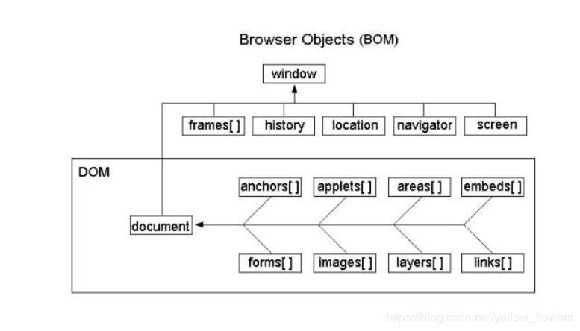

**alert() or window.alert()**

**propmpt() or window.prompt()**

**eval()**

**document.write(“welcome”);**

**window.document.write(“welcome”);**

**DOM API (Document Object Model Application programming interface). Lot of programming language provided class, function or methods which help to read, write and update html contents dynamically.**

**Java, Asp.net, Python, JavaScript etc.**

**DOM Hierarchy**

**Index.html**

**Html**

**Head body**

**Script div content(textNode)**

**Style p**

**Meta**

**Title**

**Storage object part of html5 features**

**sessionStrorage.setItem(“key”,value);**

**localStrorage.setItem(“key”,value);**

**sessionStrorage.getItem(“key”);**

**localStorage.getItem(“key”);**

**sessionStrorag.remove(“key”);**

**localStorage.removeItem(“key”);**

**synchronous and asynchronous**

**synchronous statement**

**document.write(“first statement”);**

**document.write(“second statement”);**

**document.write(“third statement”);**

**asynchronous statement**

**document.write(“first statement”);**

**document.write(“second statement”); asynchronous**

**document.write(“third statement”); asynchronous**

**synchronous function call**

**fun1();**

**fun2()**

**fun3()**

**asynchronous function call**

**fun1();**

**fun2() asynchronous**

**fun3()**

**client server communication as synchronous**

**1st req**

**2nd req**

**3rd req**

**client Server**

**client server communication as asynchronous**

**1st req**

**2nd req**

**3rd req**

**client Server**

**AJAX : Asynchronous JavaScript and XML**

**XMLHttpRequest**

**ActiveXObject**

**In JavaScript 3 pre defined function part of window object**

**setTimeout() : 1st parameter callback function name or function body and 2nd parameter time.**

**setInterval()**

**clearInterval()**

**promise**

**fetch**

**Observable**

**User defined object**